**Daily Scrum or Standup Meeting**

Team name: ________Group 2_________________

Scrum Master: ______Emily_________________

Date:_______11/2/22________________________

| **Team Member** | **What did you do since the last scrum?** | **What do you plan to do before the next scrum?** | **What obstacles do you have?** |
| --- | --- | --- | --- |
| Emily | Modified drink price | Move it to models to auto save in the database, conditionally show UI based on user group | Time |
| Andre Nguyen | Created some unit tests | Wrap up some more tests and update the documentation | Moving to Salt Lake City! 😅 |
| Maris Hurst | Brainstormed solutions to drink customization | Start working through drink customization | History midterm |
|  |  |  |  |
|  |  |  |  |

# Burndown

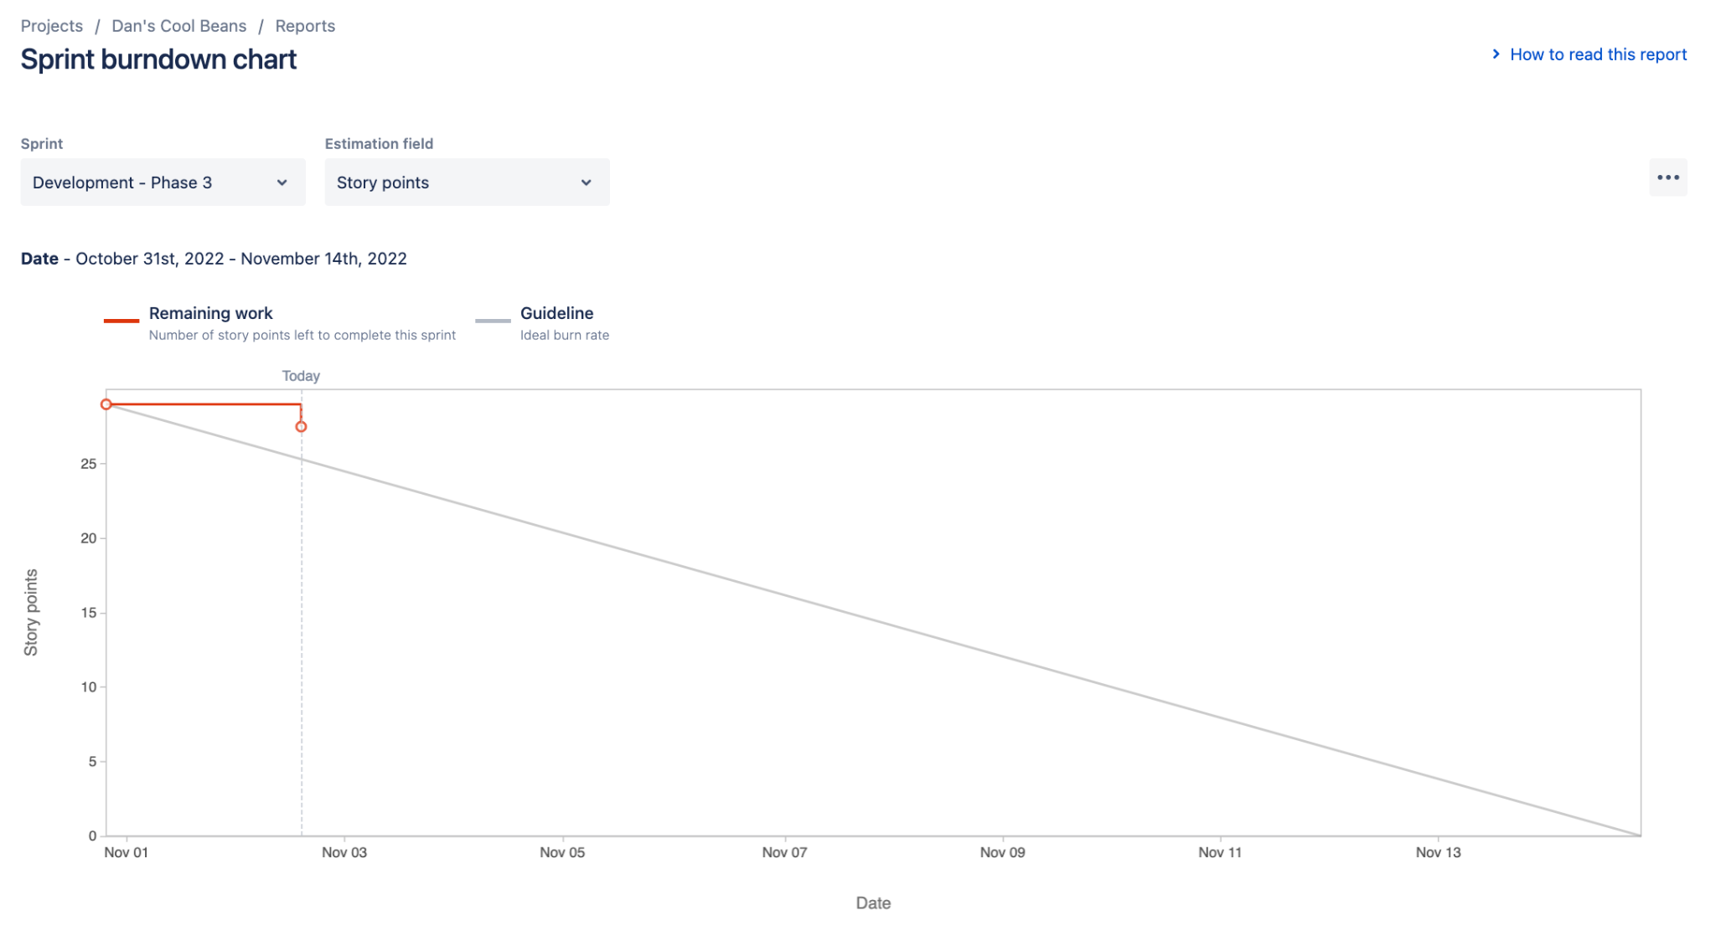

# Screenshot of you project board

